NETWORK THREATS AND MITIGATION & PHYSICAL SICURITY AND RISK
- Create a table listing 5 common network threats (such as phishing, DDoS, man-in-the-middle, malware, and password attacks), and for each, write one real-world example from an app or service you use (like WhatsApp, Instagram, or Paytm).
Answer
Common Network Threats & Real-World Examples
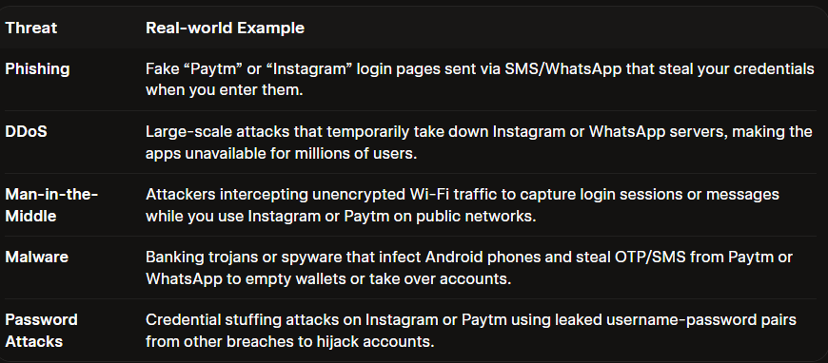

Key Takeaways
- Phishing is the most common threat on messaging apps like WhatsApp and Instagram.
- DDoS attacks are increasingly targeting financial services, especially in India.
- MitM attacks exploit weak HTTPS implementation in mobile apps.
- Always verify URLs, enable 2FA, and avoid public Wi-Fi for sensitive transactions!
- Simulate a brute-force attack scenario by writing a simple Python script that tries to guess a 4-digit PIN code by checking all possible combinations against a preset value. The script should print the number of attempts it took to guess the correct PIN.
Answer
What is a Brute-Force Attack?
A brute-force attack is a trial-and-error method where an attacker systematically tries all possible combinations of a secret (like a password, PIN, or encryption key) until the correct one is found.sentinelone+1

Key Concepts
1. Search Space (Total Combinations)
The total number of possible combinations depends on:
- Length of the secret (number of characters/digits)
- Character set size (digits, letters, symbols)
Formula:
$$\text{Total Combinations}={\left(\text{Character Set Size}\right)}^{\text{Length}}$$
2. Time to Crack
Time depends on attempt speed (guesses per second):
$$\text{Time}=\frac{\text{Total Combinations}}{\text{Attempts per Second}}$$

- Attack Scenarios

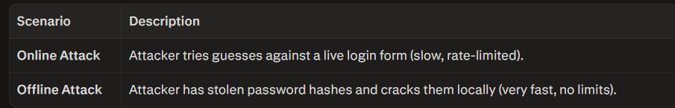
4. Why Brute-Force Works
- Weak passwords: Short length, common patterns (1234, password, admin123)
- No rate limiting: Apps that don't block after failed attempts
- No account lockout: Unlimited retry attempts allowed
- Predictable patterns: Users choose easy-to-guess secrets
Python code
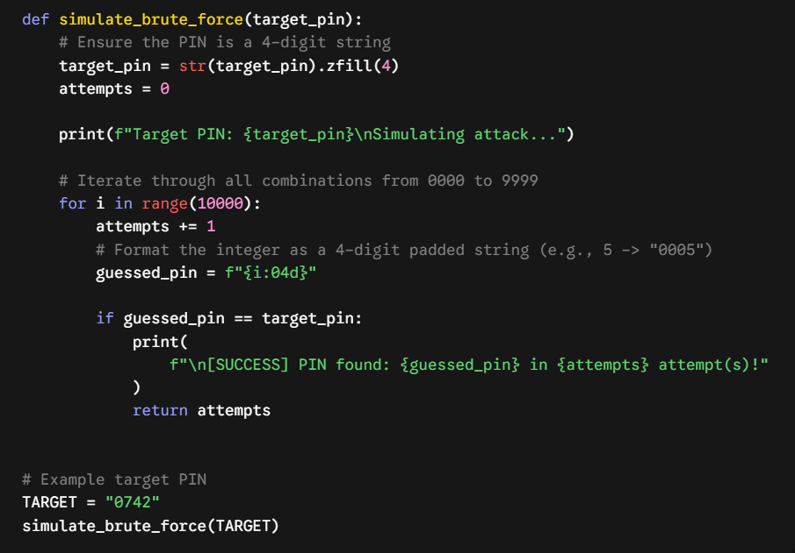
  - List 4 physical security risks that could affect a server room hosting a popular app like Zomato or BookMyShow, and suggest one mitigation step for each risk.

Physical Security Risks
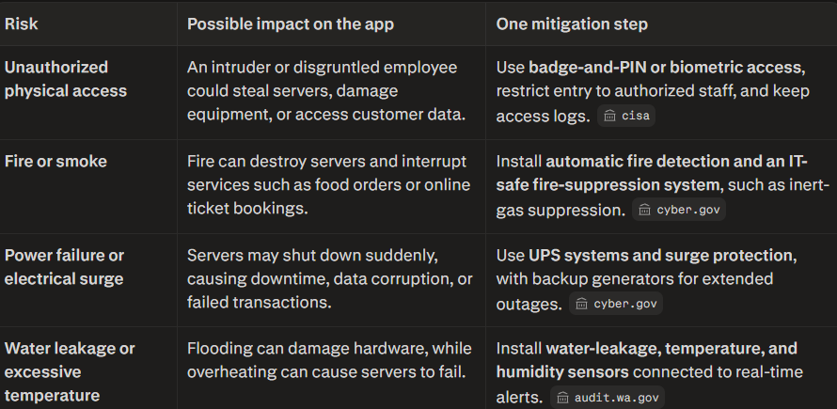

- Draw a simple floor plan (hand-drawn or digital) of a small office and mark at least 3 physical security measures you would implement to protect network equipment (such as CCTV, biometric access, or cable locks).
Answer
- Network Operations Center (NOC) Secure Room: Critical infrastructure like the server rack and main patch panel is isolated in a lockable room, away from high-traffic areas.
- Biometric Scanners: All entrances to the office and the NOC Secure Room require a biometric (fingerprint or hand geometry) scan, restricting access to authorized personnel only.
- CCTV Surveillance: A 360-degree camera with motion detection and continuous recording is positioned in the corner of the secure room.
- Rack Cable Locking System: All individual data cables are secured within the server rack to prevent unauthorized physical tampering or network sniffing.
- Perimeter Monitoring (Window Sensors): While the secure room is preferred without windows, this layout includes perimeter window sensors as a defense-in-depth measure.
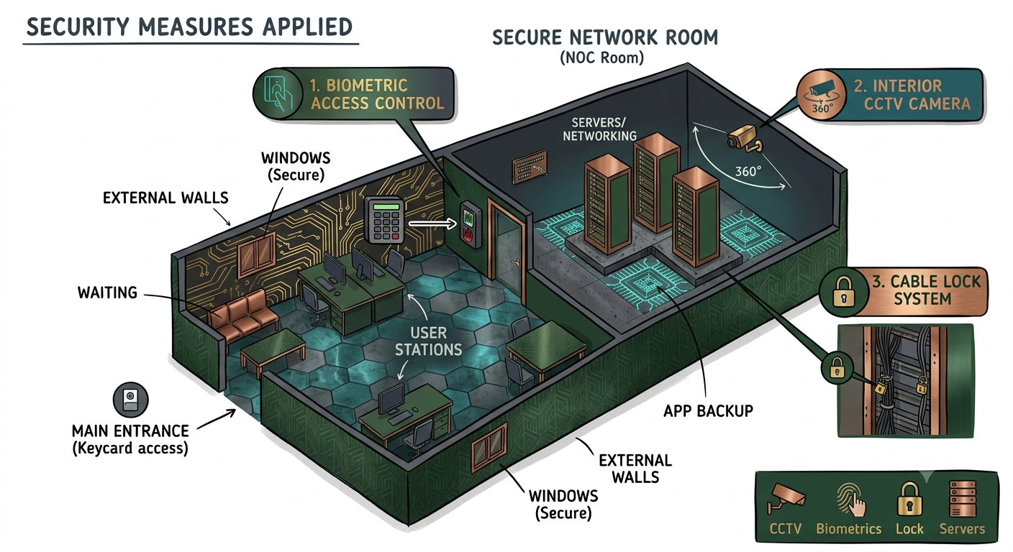

- Use ChatGPT or a similar AI tool to generate a checklist of 7 actions a network admin should take to mitigate risks from both network threats and physical security breaches, then review and edit the checklist to make it specific for a college computer lab environment.
Answer

7-Point Security Checklist for a College Computer Lab (Short Version)
- Strict access control and authentication
  - Unique logins for each user; no shared accounts.
  - MFA for staff/admin access; standard users for students.
  - Auto lock/logoff on idle; force sign-out after each session.
- Network segmentation and service restriction
  - Dedicated VLAN for lab PCs, printers, and IoT.
  - Allow only required ports/protocols to internet.
  - Disable unused services/ports on switches and PCs.
- Hardened, patched endpoints
  - Standard locked-down image for all lab PCs.
  - Host firewall + endpoint protection enabled everywhere.
  - Automated, tested patching for OS and common apps.
- Monitoring, logging, and review
  - Central logs for switches, firewall, DHCP/DNS, and PCs.
  - Alerts for suspicious logins, traffic, or new devices.
  - Weekly log reviews; retain 30–90 days of history.
- Physical access and hardware security
  - Restricted lab entry; ID/sign-in where possible.
  - Locked racks/cabinets; secured cabling and ports.
  - Cable locks on devices; maintained asset inventory.
- Secure peripherals and removable media
  - Block or control USB mass storage on lab PCs.
  - Use secure file drop-box instead of personal USBs.
  - Access-controlled printers; regular job clearance.
- Backups, recovery, and incident response
  - Regular images/backups of lab PC baseline and servers.
  - Documented steps to isolate, investigate, and rebuild.
  - Yearly tabletop exercise for common lab incidents.

